What is the Optimum Time to Stimulate PBMCs
Posted by Luke Doiron on May 6, 2015 8:32:08 AM
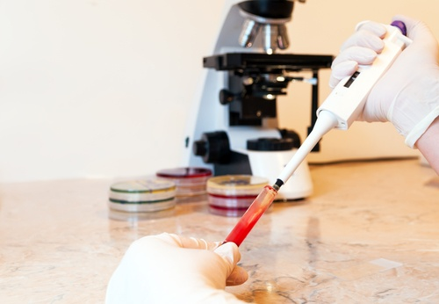
One of the most popular specimen collections we provide for researchers is our carefully sourced and highly annotated human peripheral blood samples; these come both from normal donors and from patients with cancer or autoimmune/inflammatory disorders. Peripheral blood mononuclear cells (PBMCs), consisting mainly of monocytes and lymphocytes, can be deployed in a wide range of applications, including drug discovery and immune response assessment.
The immune cells found in PBMCs are frequent targets of in-vitro stimulation. Using a range of stimuli, reagents, measurement goals and other parameters, researchers have a useful model to investigate the cellular and molecular mechanisms that mediate both protective and harmful immune responses. This knowledge is very important in studying how the body may react in vaccine clinical trials or in gaining a deeper understanding about the role of PBMC immune activities in cancer.
There is no one set method or optimum time for stimulating PBMCs, because protocols vary widely, depending on your research target. Here we offer a few protocols that may help with your particular research:

Human cytokine-producing cells
Cytokines, small soluble proteins, play a critical role in immunity and inflammation. Cytokines help regulate cell growth and differentiation and mediate normal and pathological immune responses. Researchers find them valuable tools for investigating immunological function and disease origination.
IL-2+, TNF-α+ and IFN-γ+ human cells: Stimulate PBMCs for 6 hours with PMA, calcium ionophore, or ionomycin, in the presence of a protein transport inhibitor if intracellular staining is desirable.
IL-1 α+ , IL-6+, IL-8+, and GRO- α+ human cells: Stimulate PBMCs for 4 hours with LPS in the presence of a protein transport inhibitor if you wish to do intracellular staining.

Anti-human CD28 antibody
After isolation of PBMCs using Ficoll-Paque, suspend them in your chosen medium, then include the cells with soluble NA/LE format of CD3mAb in culture for 3 days.

Human TH1/TH2/TH17 phenotyping
Stimulation of T helper cell subsets is reported to be useful for quickly inducing and characterizing polyclonal cytokine-producing cells. Normal PBMCs are stimulated at a concentration of 1-10 million cells/ ml for 5 hours with PMA/Ionomycin medium and protein transport inhibitor.
CMI response in antiretroviral therapy-naïve HIV-1-infected patients
This protocol investigated the optimal procedure for evaluating the T-cell mediated immune (CMI) response of HIV-1 infected, ART-naïve patients. Researchers found that when the PBMCs were stimulated for longer periods of time, i.e. overnight as compared with a 6-hour stimulation-time interval, an increased frequency of CD8+-specific T-cell responses was noted after intracellular cytokine staining (ICS) in the PBMCs without a change of functionality.

Human herpesvirus 6 (HHV-6) from PBMCs
According to the HHV-6 Foundation, human herpesvirus 6 (HHV-6) is actually two closely related herpes viruses known as HHV-6A and HHV-6B known to infect nearly all humans, usually before two years. In infants, HHV-6 usually causes fever, diarrhea, and roseola rash though less commonly it may induce febrile or intractable seizures, or encephalitis.
HHV-6 is latent but can reactivate later in life nearly anywhere, including brain, lungs, heart, and kidneys. HHV-6 reactivation in brain tissue can cause cognitive dysfunction, disability and even death.
Researchers are also troubled by studies showing that HHV-6 might be implicated in patients with chronic neurological disorders such as MS or epilepsy, and are trying to determine whether these disease associations can be proven.
Human PBMCs are useful in obtaining HHV-6 isolates. First, lymphocytes are separated, then stimulated with PHA for 48 hours, after which 10% human IL-2 is added to the culture. Researchers note that this is a very difficult virus to isolate.

